Software Engineering Group 11

SE_11_PP_03

Project Plan – Use-Cases

Author: Kieran Dunbar (kid10), Qiaoyang Zheng (qiz)

Configuration Ref: SE_11_PP_03

Date: 2014-10-30

Version: 1.1

Status: In Review

Department of Computer Science

Aberystwyth University

Aberystwyth

Ceredigion

SY23 3DB

Copyright © Aberystwyth University 2014

Table of Contents

1. Introduction 3

1.1. Purpose of Document 3

1.2. Scope 3

1.3. Objectives 3

2. Use-Case Diagram 4

3. Use Case Descriptions 5

3.1. Android Application (RPSRrec) 5

3.2. Web Application (RPSRview) 6

3.3. Server Application (RPSRsrv) 6

4. REFERENCES 7

5. DOCUMENT HISTORY 7

# Introduction

## Purpose of Document

The purpose of this document is to be an individual part of the final project plan, this is being kept as a separate document to allow for version control and drafting of this particular section.

## Scope

This document aims to be a Informative Use Case diagram with descriptions and usage scenarios.

## Objectives

This document covers:

* Interactions a user will have with the system
* The difference of the web/android system

# Use-Case Diagram

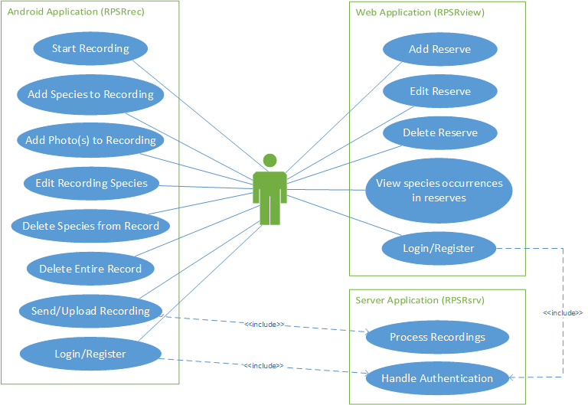

# Use Case Descriptions

## Android Application (RPSRrec)

|  |  |  |
| --- | --- | --- |
| **Requirement** | **Use Case** | **Description** |
| FR1 and FR2 | Start Recording | User should be able to start a recording by entering details of the reserve. He/she may also have to Login or Register (see use case below). |
| FR3 and FR4 | Add Species to Recording | User should be able to add a new or existing species to the recording by entering details such as location, abundance and any comments. |
| FR4 | Add Photo(s) to Recording | User should also be able to add general and specimen photos to the species occurrence in the recording. |
| FR5 | Edit Recording Species | The user should also be able to edit any of the species specified in a particular recording. |
| FR5 | Delete Species from Record | The user should be able to delete a species occurrence from a recording. |
| FR5 | Delete Entire Record | The user should also be able to delete an entire recording, including all of its associated species occurrences. |
| FR6 | Send/Upload Recording | The user should be able to submit details of the recording through to the server (RPSRsrv) once finished. |
| N/A - Optional Feature | Login/Register | The user should be able to register for an account and subsequently be able to login using that account to use the application. |

## Web Application (RPSRview)

|  |  |  |
| --- | --- | --- |
| **Requirement** | **Use Case** | **Description** |
| FR8 | Add Reserve | User should be able to create a new reserve by entering details such as it’s name, location and description. |
| FR8 | Edit Reserve | The user should also be able to edit a reserve’s details. |
| FR8 | Delete Reserve | The user should also be able to delete a reserve from the system. |
| FR9 | View species occurrences in reserves | The user should be able to view all recordings (including all details of any species occurrences in that recording) from a particular reserve. |
| N/A - Optional Feature | Login/Register | The user should be able to register for an account and subsequently be able to login using that account to use the application. |

## Server Application (RPSRsrv)

|  |  |  |
| --- | --- | --- |
| **Requirement** | **Use Case** | **Description** |
| FR7 | Process Recordings | When the user submits a recording (or multiple recordings), the server should process these and store them in the database. |
| N/A - Optional Feature | Handle Authentication | When the user attempts to log in or register, the server should handle this by either checking login details or by adding a new user to the database. |

# REFERENCES

N/A

# DOCUMENT HISTORY

|  |  |  |  |  |
| --- | --- | --- | --- | --- |
| Version | CCF No. | Date | Changes made to document | Changed by |
| 1.0 | N/A | 21/10/14 | Document Created and Structured | Add20 |
| 1.1 | N/A | 28/10/14 | Restructured Into new Template Supplied by als48. | Tcg2 |